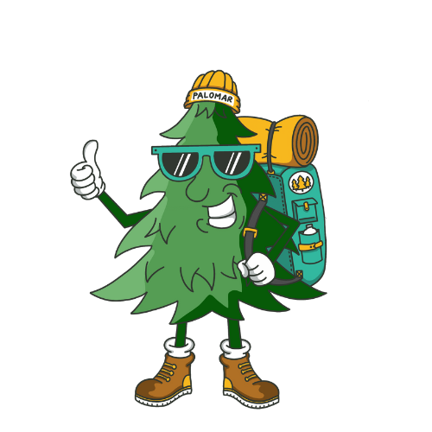
What to Bring to Horse Camp 2026
Our Pal Omar Wants To Help You Pack For Camp!
- Boots with a ½ inch heel and very little tread
- ASTM/SEI Certified Riding helmet less than 5 yrs. Old
(OPTIONAL: We have helmets campers can use)
- Tennis shoes
- Flip flops or sandals
- Jacket and/or Sweatshirt
- Jeans/Pants for riding : Stretchy pants for riding if preferred, such as leggings, yoga pants, running pants, or breeches
- Athletic shorts
- One piece modest swim suit
- Sleeping bag/bedding and pillow
- Bath towel and pool towel
- Toiletries (soap, shampoo, deodorant, toothbrush, toothpaste)
- FORMS: Medication Form (if your camper has medications) Medicine in original packaging
- Flashlight
- Bible, pens, paper, envelopes (pre-addressed suggested), stamps
- Water Bottle
- Bug spray and Sunscreen
- Camera (not cell phone)
- Money for gift shop
- 80’s Attire for Theme Day
Please Note:
In order to respect others at camp and to encourage modesty, we ask that
all shorts be at least mid-thigh in length and all tank tops have at least a
two inch strap and cover bras completely. If you are purchasing new boots,
plan on wearing them a couple of weeks before camp to avoid blisters and
sore feet. Please mark all articles brought to camp and try to avoid bringing
expensive items.
What NOT to Bring
- Electronics, cellphone, iPad, iPod, portable handheld gaming devices, watches that can communicate, etc.
- Inappropriate content on clothing
- Spurs
- Cigarettes, e-cigs, etc. Guns, knives, fireworks, illegal substances
- Anything that might get you in trouble!
Please note: In our experience, we have found that electronics are a distraction at camp. If there is an issue where you need to get ahold of your camper, call our office. If there is an issue where your camper needs to get ahold of you, our camp leadership will oversee their conversation with our office phones. Also, we will be taking pictures all week and will post them on our website. If you have any questions about this issue, please call our office at (760) 742-3400.

