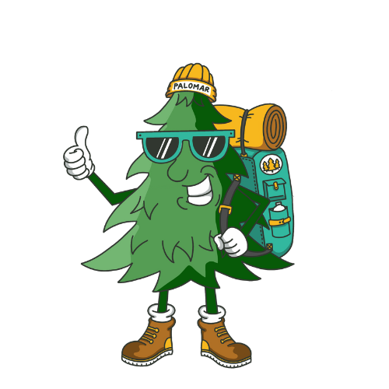
What to Bring to Adventure Camp 2026
Our Pal Omar Wants To Help You Pack For Camp!
- Hiking shoes (broken in please)
- tennis shoes,
- 2 pairs of long pants,
- 3 shorts,
- 8 socks,
- 8-9 pairs of underwear (remember, you’re in the woods!),
- a pair of thick socks to sleep in,
- 6 t-shirts, 1 white t-shirt, 2-3 long sleeved shirts,
- jacket/ sweatshirt,
- towel and toiletries
- reusable water bottle,
- bug spray,
- sunscreen,
- CHAPSTICK,
- flashlight/ headlamp,
- bible with pen and journal, envelopes (pre-addresed) and stamps
- swim shorts (no speedos please),
- hat and bug net to go over hat,
- money for the gift shop

Optional: Foldable pocket knife no fixed blades, sunglasses, beanie or shemagh to keep head warm and bugs away, trail mix/ beef jerky/ etc, gloves for the night, handwarmers, sleeping bag/ ground pad, hiking backpack: these items are provided by PCCC, but it is recommended that campers bring their own if they have them.

Please Note: If you are purchasing new boots, plan on wearing them a couple of weeks before camp to avoid blisters and sore feet. Please mark all articles brought to camp and try to avoid bringing expensive items.

What NOT to Bring
- Electronics, cellphone, iPad, iPod, portable handheld gaming devices, watches that can communicate, etc.
- Inappropriate content on clothing
- Cigarettes, e-cigs, etc. Guns, knives with fixed blades, fireworks, illegal substances
- Anything that might get you in trouble!
Please note: In our experience, we have found that electronics are a distraction at camp. If there is an issue where you need to get ahold of your camper, call our office. If there is an issue where your camper needs to get ahold of you, our camp leadership will oversee their conversation with our office phones. Also, we will be taking pictures all week and will post them on our website. If you have any questions about this issue, please call our office at (760) 742-3400.

